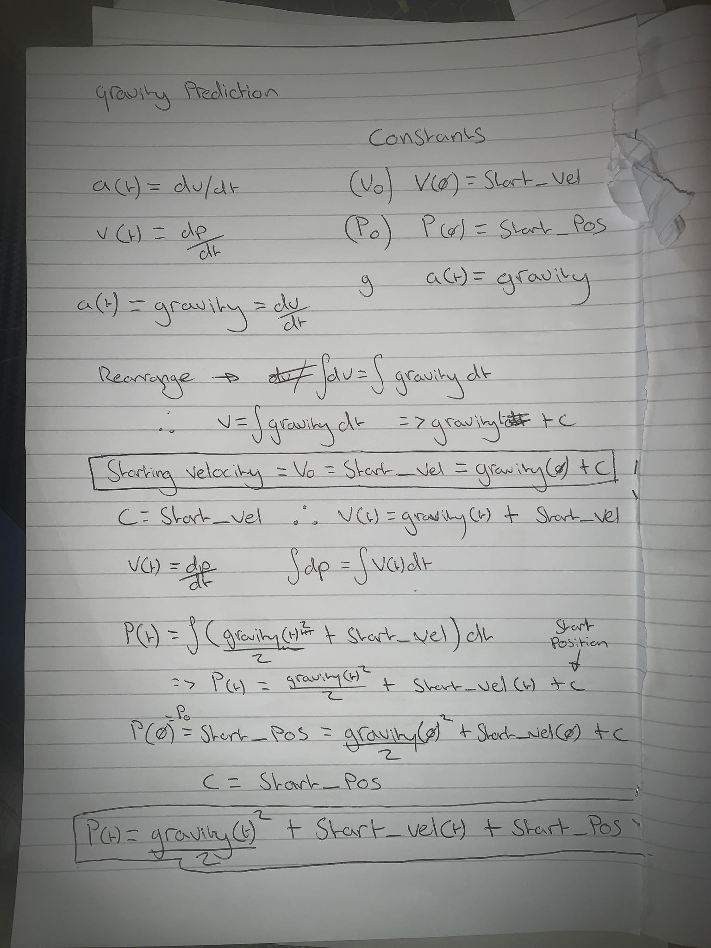

P(t) = (½) * gravity * time^2 + start_vel * time + start_pos